

14 October 2021

**Terra Industrial New Zealand Ltd**

PO Box 16 168

16 Branston Street, Hornby

Christchurch 8441, New Zealand

03 983 2333 tel

www.TerraCat.co.nz

**CLEARING USAGE DATA**

Contents

Clearing specific data 3

Clearing all usage data 7

Sometimes an error like the below pops up

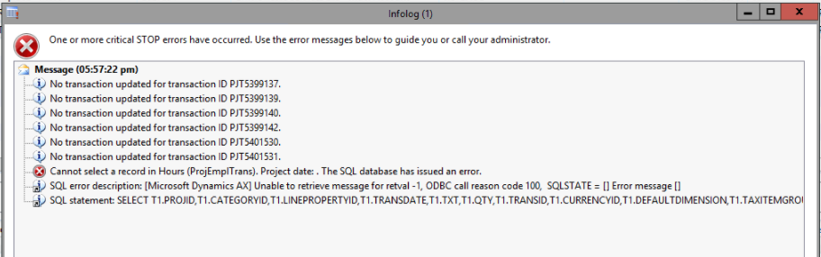

Try clearing all proj* data first by following the below steps

# Clearing specific data

1. Click File > Tools > Options

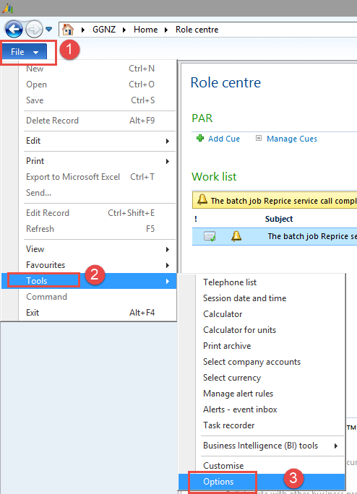

1. Click Usage data > All usage data

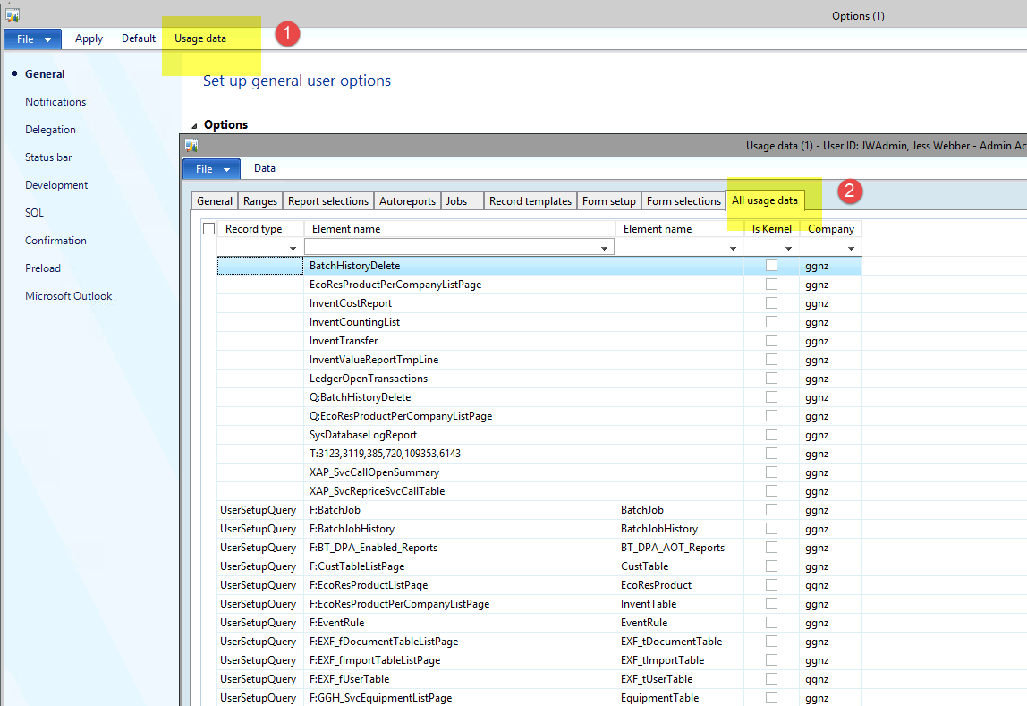

1. In the Element Name column, type in proj* then press enter (this will filter out only the project data)
2. Tick the box to the left which will select all

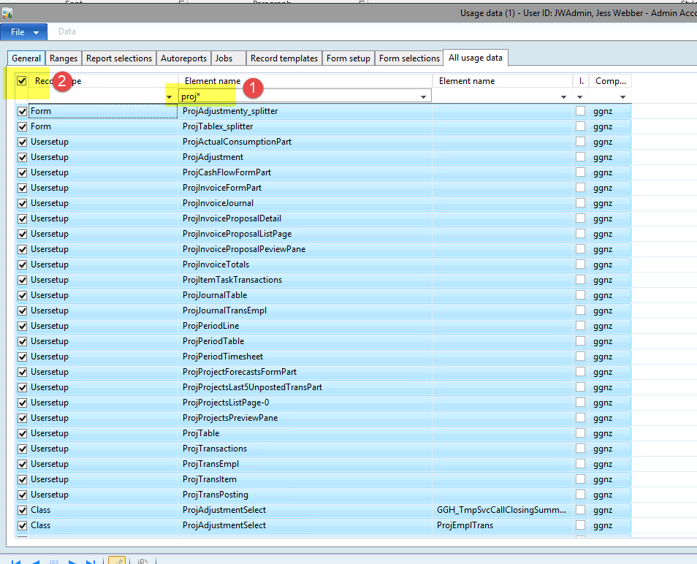

1. Click File > Delete Record

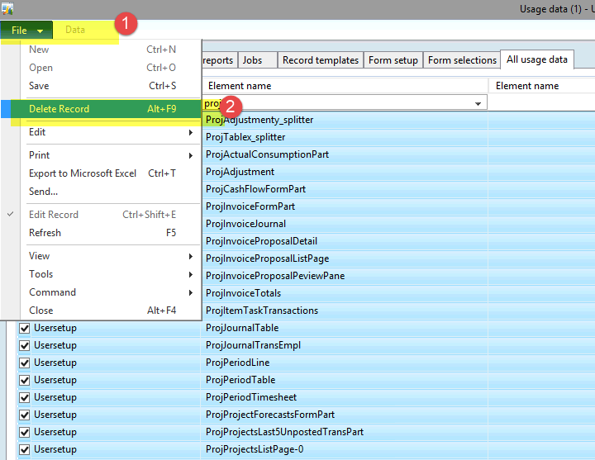

1. Click Yes

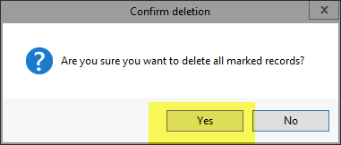

1. Now it should be empty

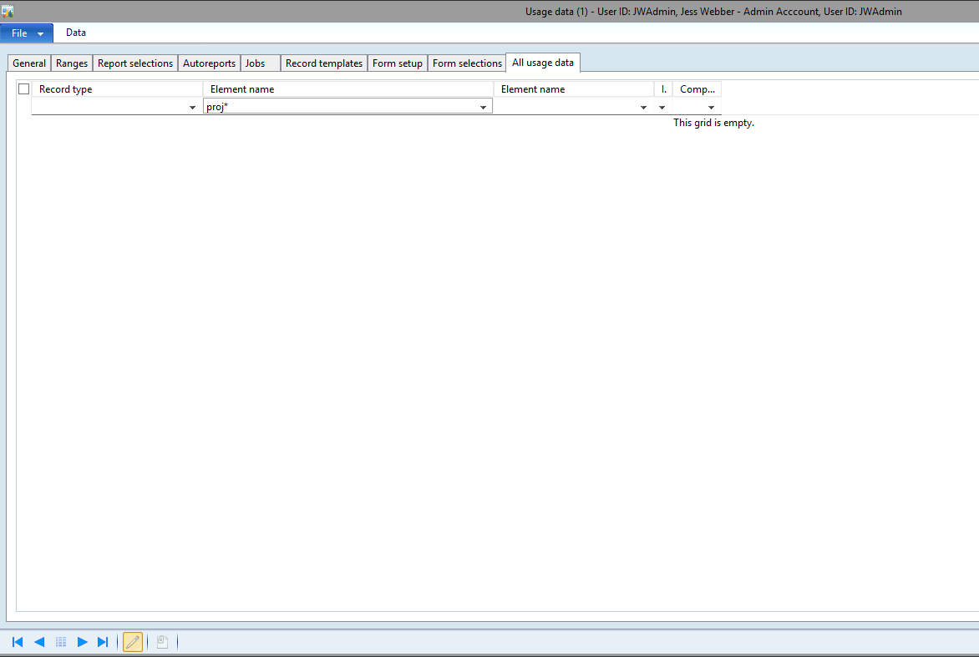

1. Do the same for the second Element Column (taking out proj* from the first column and putting it into the second) like below

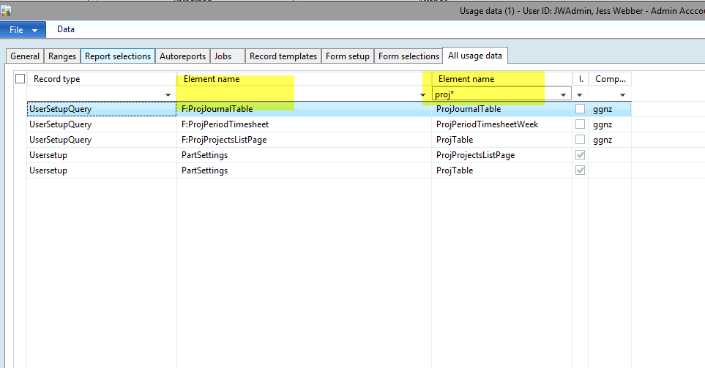

1. Once both columns have been cleared, try going back to what you were doing before and see if you are able to proceed. If still unable to, then unfortunately you will need to clear all your usage data – following the steps below.

# Clearing all usage data

Please bear in mind that clearing all usage data will unfortunately remove all personalisations (Moved columns, columns that you have added etc, your favourites will be fine however)

1. Click File > Tools > Options



1. Click Usage Data > All Usage Data



1. Tick the box to the left which will select all your usage data (making sure there are no filters in the top columns)

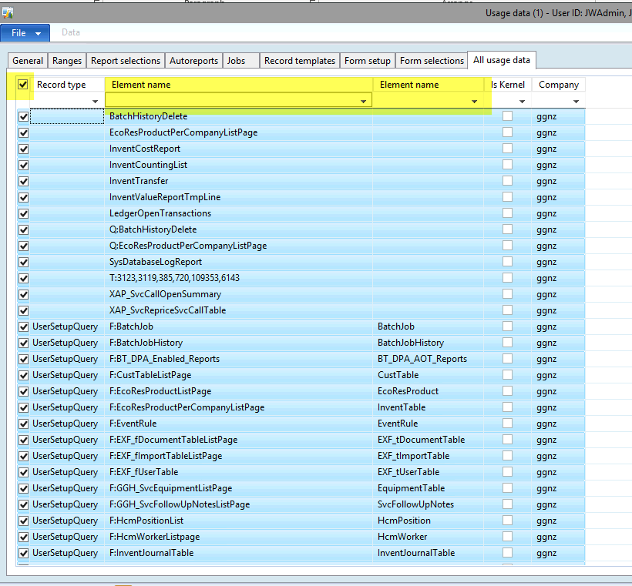

1. Click File > Delete Record

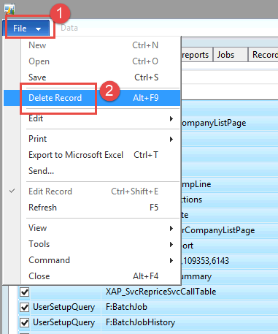

1. Click Yes



1. Now you should be able to proceed with what you were trying to do. Maybe close and reopen Naxt 😊